**The ThermoVacc Final Project Documentation**

**-Aaditya Shah, Kabir Punjwani, Avya Gupta**

***Idea:*** A system that measures and regulates temperature within an ice box so that vaccines stay in the optimal temperature range.

***Problem statement:*** There are often problems with temperature regulation of vaccines while they are being transported with no definite way for the driver of the vehicle to be informed of it.

***SDG in play:*** *SDG 3 Good health and well-being*

**

***Constraints:*** Not enough power to run the system. The peltier blocks incorporated in the project are inefficient and require a lot of power which our battery could not provide

***Solutions brainstorming:***

We first thought of adding some sort of additional coolant to the system which is triggered when the temperature is not optimal. Our ideas included flowing cold water in pipes around it or a trapdoor system holding additional ice. However, in this system we had no control over the temperature even after providing the necessary cooling. Hence, we did not go with it

Next, we thought of peltier blocks. Here we were faced with another challenge: peltiers can be quite inefficient and they heat up to a great extent which can pose issues. To battle this we used heat sinks to dissipate the heat energy from the peltier to the surroundings and a fan to further drive the energy out of the system

***Process:***

**1st Prototype:** The first prototype is a paper prototype made out of foam board. This prototype gave us an idea of the dimensions required for our icebox and the placement of the peltier blocks and heatsinks. We initially thought of making the legs of our ice box with wood but then changed plans and switched to PVC pipes.

**2nd Prototype:** The second prototype is the thermocol icebox. We cut out the large thermocol box into a smaller one using the dimensions of the paper prototype and also replaced the bottom with an aluminum sheet. We attached 4 peltier blocks in a parallel circuit with 1 breadboard and a battery. The main issue that we faced with this iteration is that the battery was not enough to power the 4 peltiers - it worked momentarily but ran out very quickly.

**3rd Prototype:** The third prototype was aimed at solving the issue of the battery. We decided to use a battery only for the temperature sensor and to power the arduino. For the pelteirs we used the mains - an AC to DC convertor. We also added relays to the circuit because we were using mains. We also switched our temperature sensor for a DHT sensor as the former was not working

**4th Prototype:** In the fourth prototype we changed our breadboard and used a larger one for a cleaner looking circuit. We reduced the number of peltiers to 3 because our project wasn’t

working with 4 as 2 of the peltiers had stopped working.

**5th Prototype:** We were facing issues with the peltiers because the heating effect was overpowering the cooling effect despite the heatsinks. We decided to add a fan so that it would further drive out the heat and so counteract the overheating. However, since we had none with us, we opened up a dysfunctional hair dryer using a hacksaw and used the fan inside it.

***Materials used:*** 1 Peltier block (40mm x 40mm), 1 DHT sensor, 1 Aluminium heat sink (40mm x 40mm x 10mm), 1 big breadboard, 2 small breadboards, 1 ice box (25cm x 25cm x 13cm from the inside), 25cm aluminum sheet, 1 mini fan, connecting wires.

***Final solution:***

* **Name of the project:** The ThermoVacc
* **Paper prototyping images/videos**

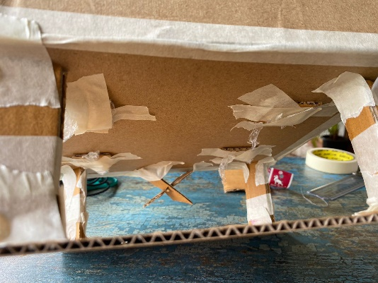

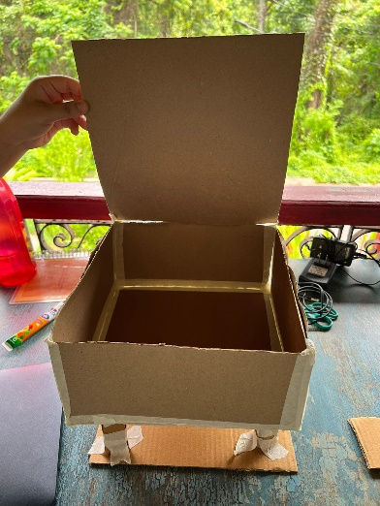

* **Final prototyping images and videos**

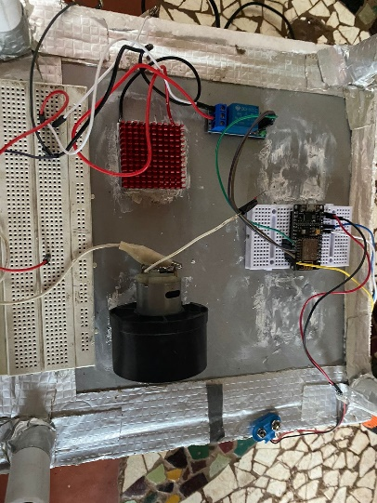

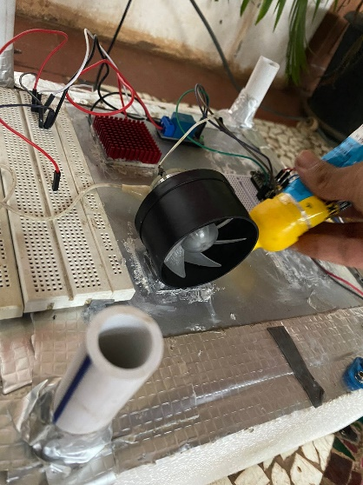

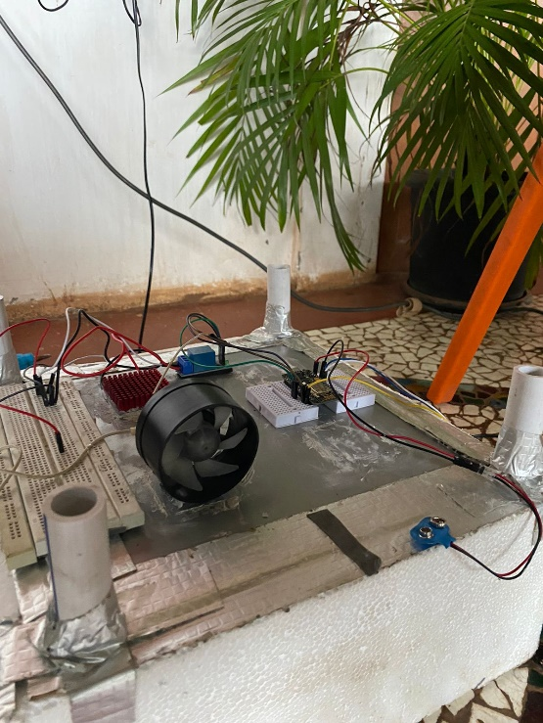

* **Programming**

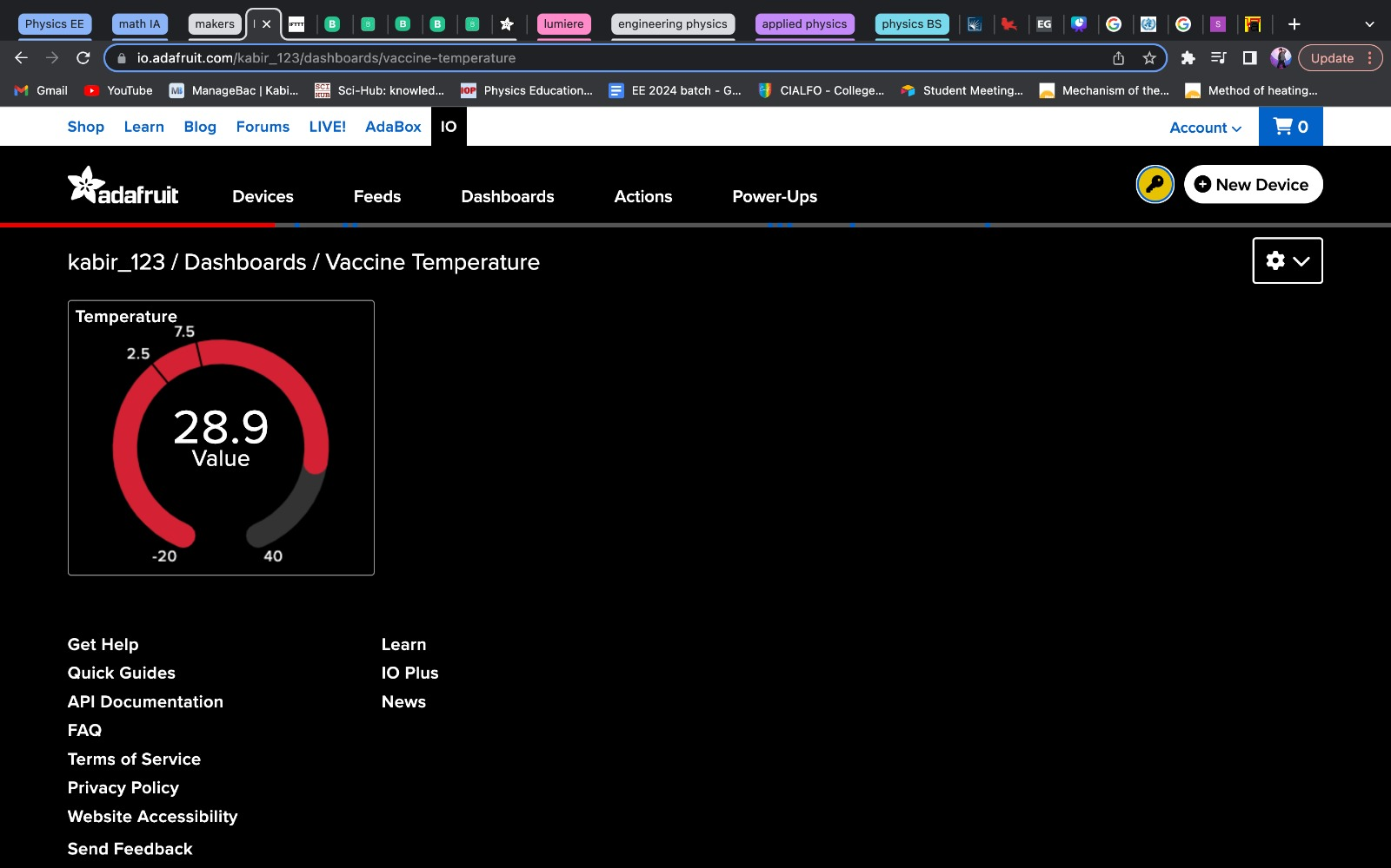

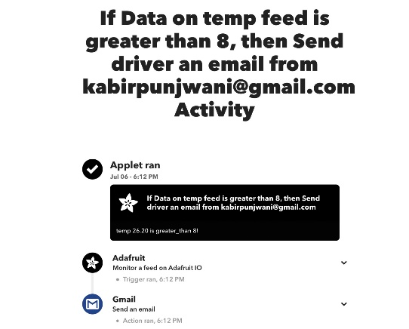

* **Tools/machines used**

Hacksaw

Jigsaw machine

* **Skills used**

Paper prototyping

Electronics

IoT

Hand Tools

Power Tools

* **References links**
  + “Peltier Module (Thermoelectric Module) - Energy Conversion Devices - KYOCERA.” n.d. KYOCERA GROUP GLOBAL SITE. Accessed July 10, 2023. https://global.kyocera.com/prdct/ecd/peltier/.
  + “Storage Best Practices for Refrigerated Vaccines-Celsius (C).” 2018. Cdc.gov. 2018. https://www.cdc.gov/vaccines/hcp/admin/storage/downloads/c-vax-temp-best-practices-fridge-c.pdf.
  + “TEC / Peltier Element Design Guide.” n.d. Meerstetter.Ch. Accessed July 10, 2023. https://www.meerstetter.ch/customer-center/compendium/32-tec-peltier-element-design-guide.
  + N.d. Who.int. Accessed July 10, 2023. <https://apps.who.int/iris/bitstream/handle/10665/68463/WHO_VB_03.18.Rev.1_eng.pdf>.

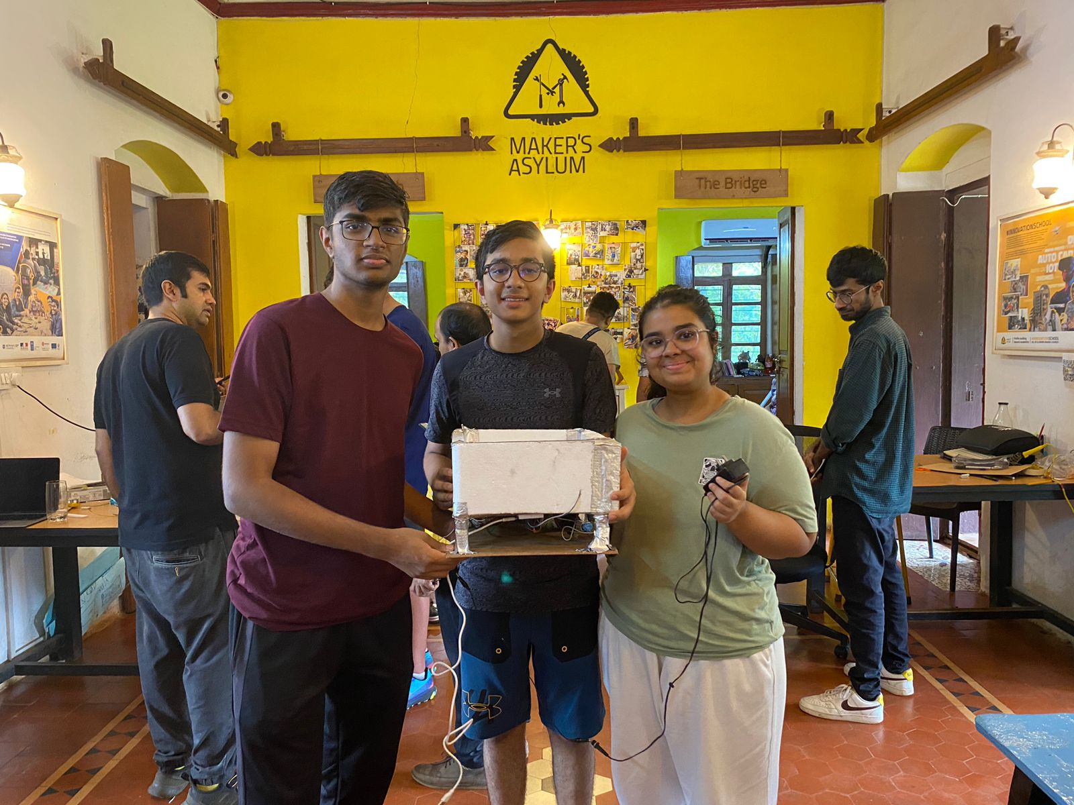

*The makers: Aaditya Shah, Kabir Punjwani and Avya Gupta*